Lab 11: Nested Loops

# Name: Hassan Shahzad

# Class: BS CS 7C

# CMS ID: 211798

## Task 01:

// this is #1 - I'll call it "CN"

for (char c = 'A'; c <= 'E'; c++)

{

for (int n = 1; n <= 3; n++)

{

printf("%c %d\n", c, n);

}

}

printf("\n\n");

// this is #2 - I'll call it "AB"

for (int a = 1; a <= 3; a++)

{

for (int b = 1; b <= 3; b++)

{

printf("%d-%d ", a, b);

}

/* your code comes here!!! */

}

## Task 03:

#define _CRT_SECURE_NO_WARNINGS

#include <stdio.h>

#include <stdlib.h>

#include <time.h>

void delay(int);

int main()

{

int a;

printf("Which base: ");

scanf("%d", &a);

for (int thous = 0; thous < a; thous++)

{

for (int hund = 0; hund < a; hund++)

{

for (int tens = 0; tens < a; tens++)

{

for (int ones = 0; ones < a; ones++)

{

printf(" %d%d%d%d\r", thous, hund, tens, ones);

delay(10);

}

}

}

}

printf("\n");

return EXIT_SUCCESS;

}

void delay(int milliseconds)

{

long pause;

clock_t now, then;

pause = milliseconds * (CLOCKS_PER_SEC / 1000);

now = then = clock();

while ((now - then) < pause)

now = clock();

}

// Q1): It will print an endless loop by continuously increasing one by one.

// Q2): It will print numbers starting from 0000 to 7777.

## Output:

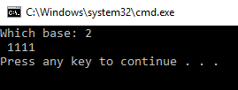

## Task 05:

#include <stdio.h>

#define _CRT_SECURE_NO_WARNINGS

int main()

{

int a, b, c;

printf("x\t|\t1\t2\t3\t4\t5\t6\t7\t8\t9\n");

printf("========+==============================================================================\n");

for (a = 1; a <= 12; a++)

{

printf("%d\t|\t", a);

for (b = 1; b <= 9; b++)

{

c = b*a;

printf("%d\t", c);

}

printf("\n");

}

}

## Output:

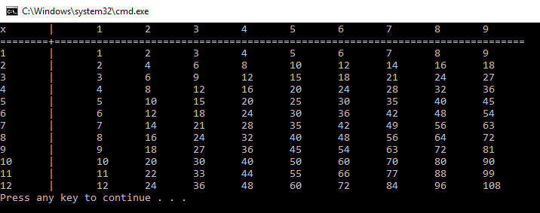

## Task 07:

#include <stdio.h>

int main()

{

int a, b;

for (a = 1; a <= 9; a++)

{

for (b = 0; b <= 9; b++)

printf("%d%d, %d+%d = %d\n", a, b, a, b, a + b);

}

## }

## Output:

## 

## Task 09:

#include <stdio.h>

int main()

{

for (int i = 1; i < 10; i++)

for (int j = 0; j < 10; j++)

for (int k = 0; k < 10; k++)

{

if (((i*i*i) + (j*j*j) + (k*k*k)) == (i * 100 + j * 10 + k))

printf("%d\n", (i * 100 + j * 10 + k));

}

return 0;

}

## Output:

